|  |  |
| --- | --- |
| **Name:** | MANSI UNIYAL |
| **Roll Number:** | 19EE10039 |

**Experiment No. 4**

**Name of the Experiment: FULL WAVE RECTIFICATION**

1. **Aim of the experiment**

* Explain Centre Tapped Full Wave Rectification
* Explain Bridge Full Wave Rectification

1. **Tools used:**

* Stimulation: Vlabs
* Oscilloscope
* Connecting Wires
* 4 Diodes
* Sinusoidal input voltage source
* Load resistance (400 ohms, 600 ohms)

1. **Background knowledge (brief):**

* **Rectification**

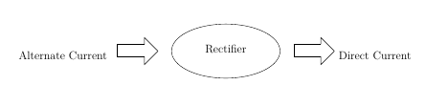

A rectifier is a device that converts alternating current (AC) to direct current (DC), a process known as rectification. Rectifiers are essentially of two types – a half wave rectifier and a full wave rectifier.

* **Full Wave Rectifier**

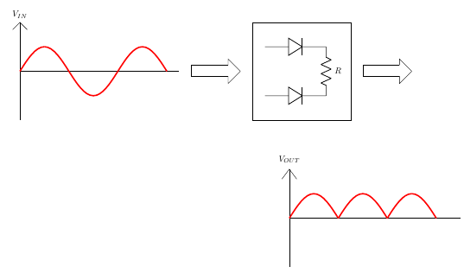

A full-wave rectifier is exactly the same as the half-wave, but allows unidirectional current through the load during the entire sinusoidal cycle (as opposed to only half the cycle in the half-wave). A full-wave rectifier converts the whole of the input waveform to one of constant polarity (positive or negative) at its output.

* Center Tapped Transformer

A Full-Wave Rectifier can be constructed using Center-Tapped transformer – which give us two shifted sinusoids so that exactly one of the waveforms is positive at one time and two diodes. As compared to the half wave rectifier we use two diodes instead of one, one of the two diodes remains in conduction in both of the half cycles. At any point in time, only one of the diodes is forward biased. This allows for continuous conduction through load.

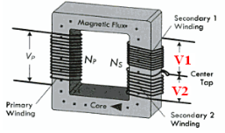 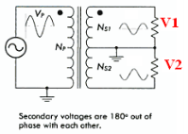

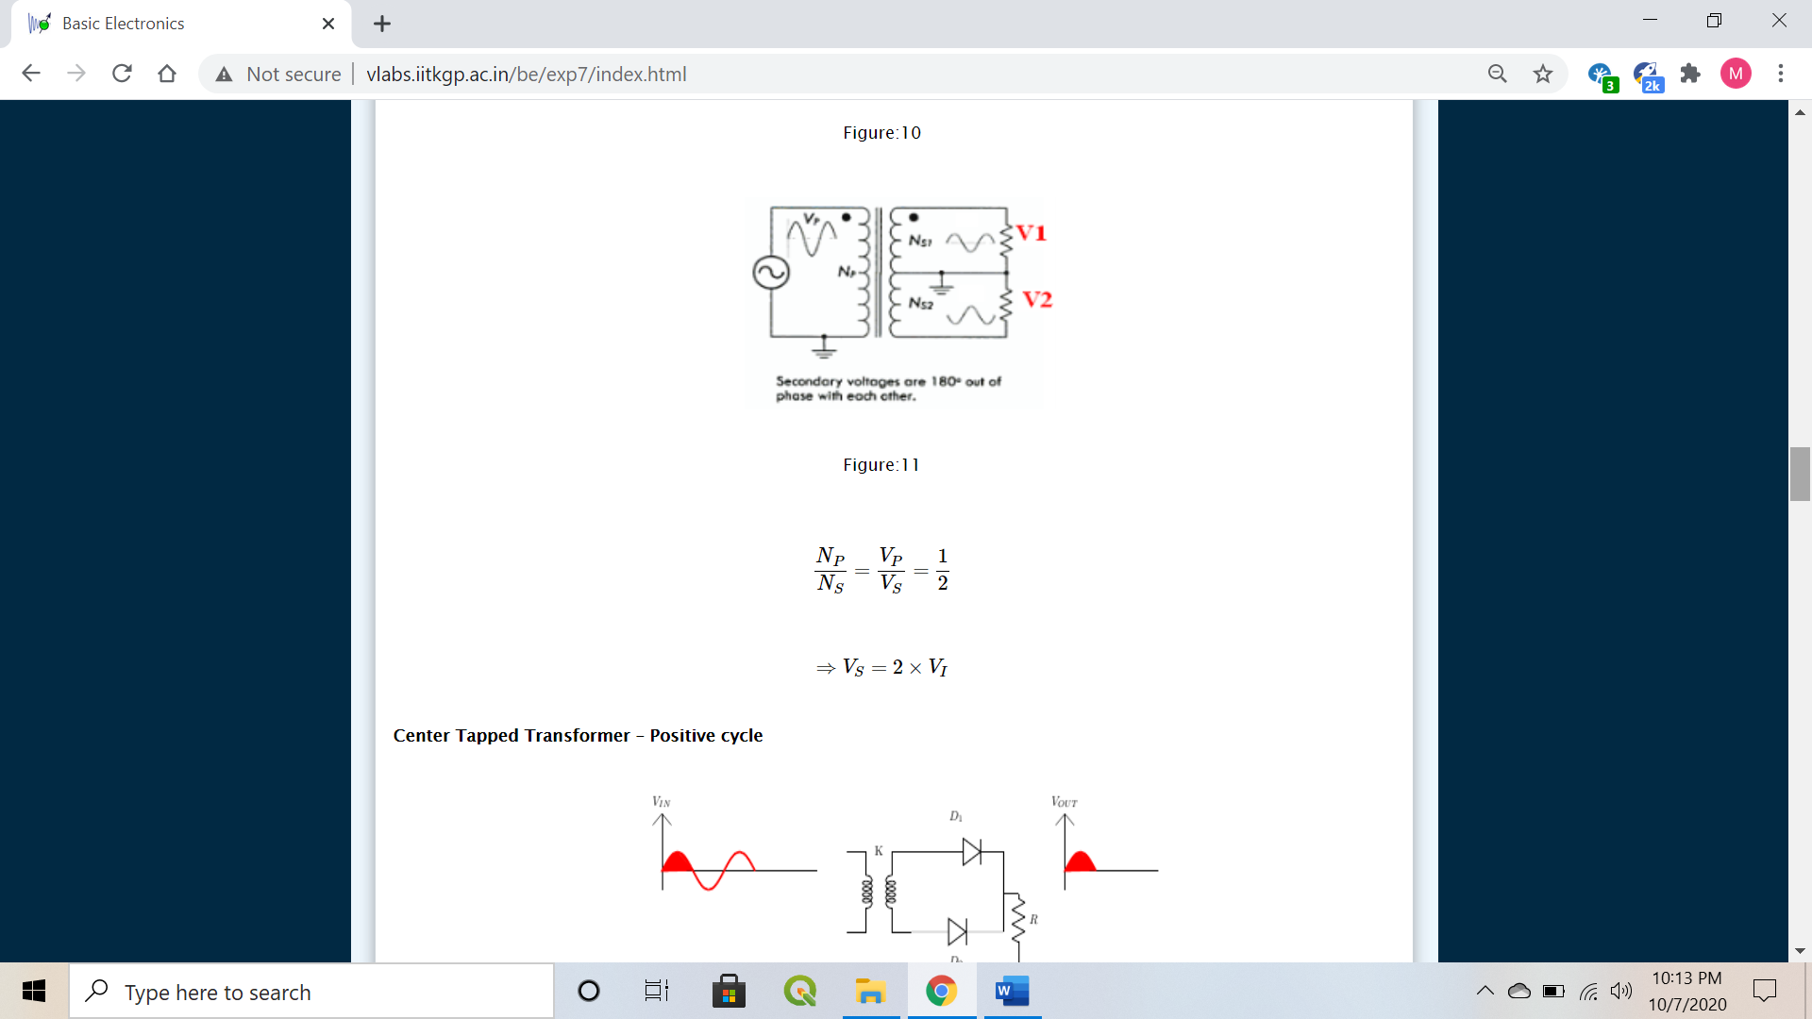

* + - * + Positive cycle

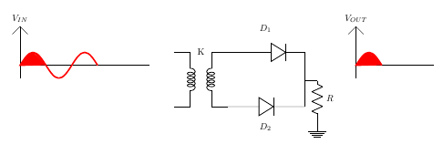

D1 is Forward Biased

D2 is Reverse Biased

VI−VO=0

⇒ VO=VI

* + - * + Negative cycle

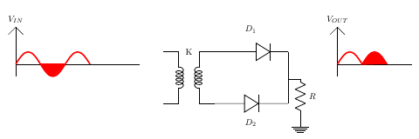D1 is Reverse Biased D2 is Forward Biased

VI−VO=0

⇒ VO=VI

* Bridge Rectifier

Bridge rectifier uses 4 rectifying diodes connected in a "bridged" configuration to produce the desired output but does not require a special centre tapped transformer, thereby reducing its size and cost. The single secondary winding is connected to one side of the diode bridge network and the load to the other side as shown below.

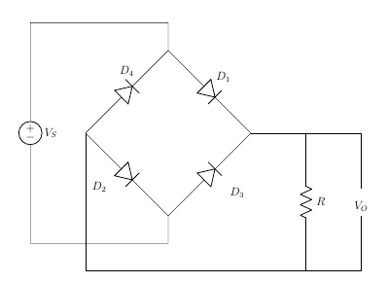

* + - * + Positive Half Cycle

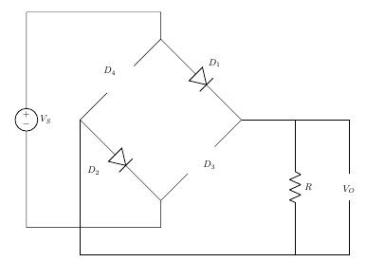D1 and D2 conduct in series

D3 and D4 are reverse biased

VI−VO=0

⇒ VO=VI

VO=VI−2×Vb

VO=VI −2×Vb −2×Ird

* + - * + 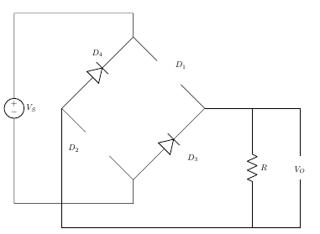Negative Half Cycle  
            
          D3 and D4 conduct in series

D1 and D2 are in reverse biased.

The current flowing through the load is the same direction as before.

VI−VO=0

⇒ VO=VI

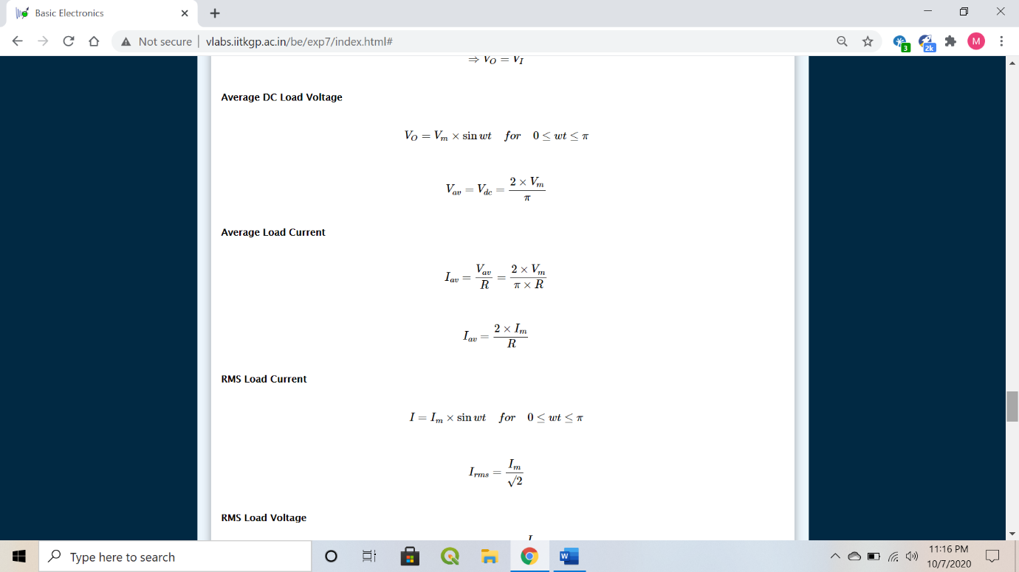

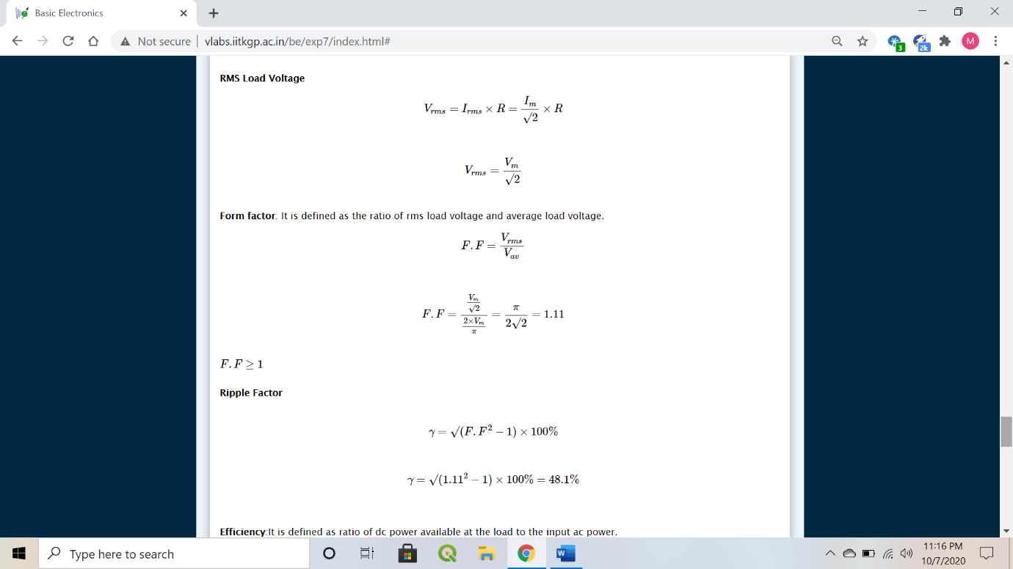

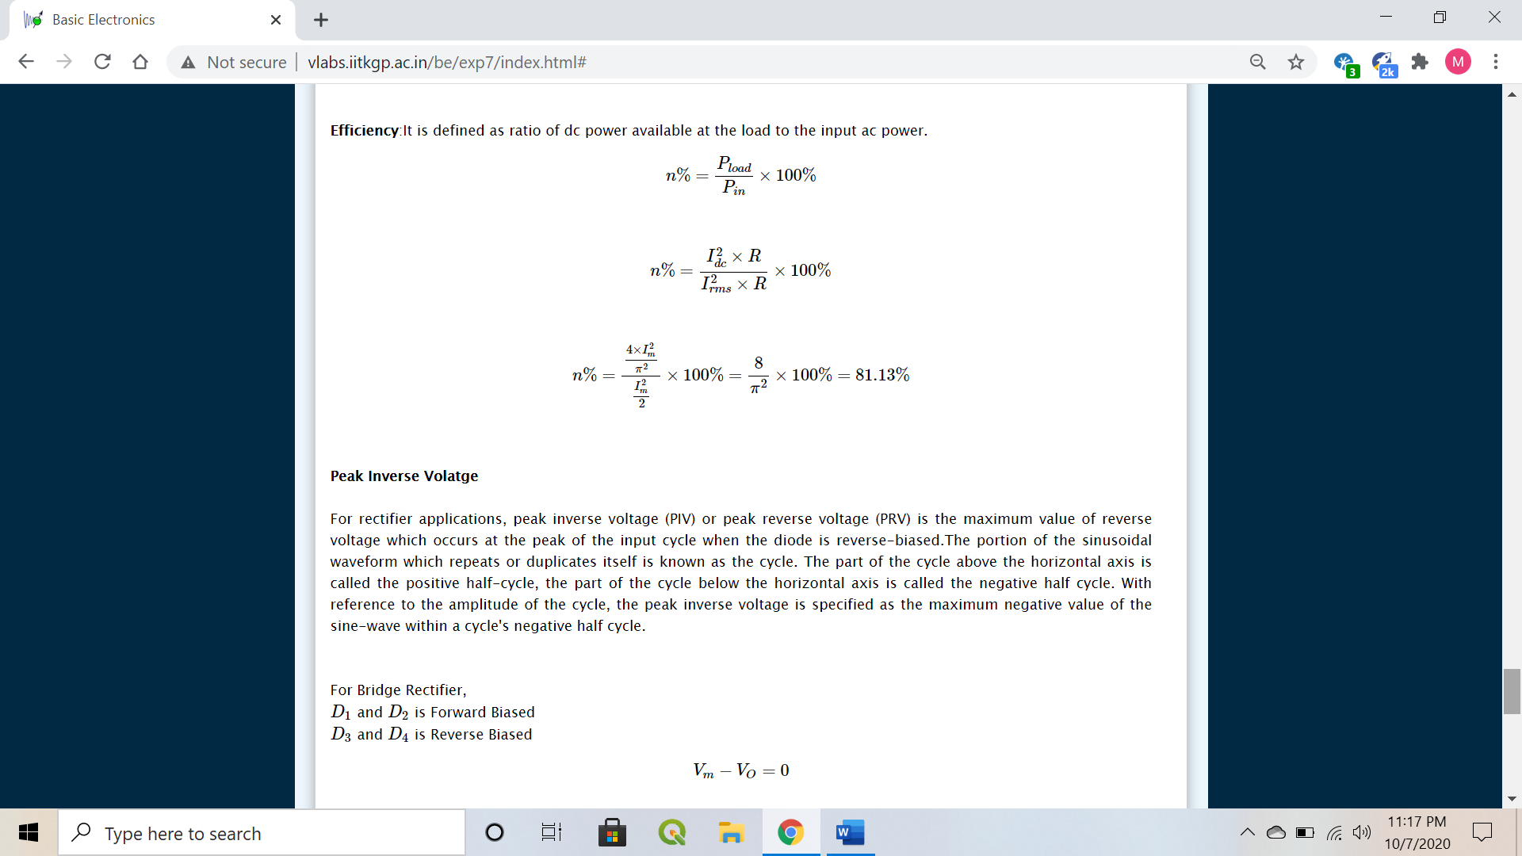

* **PIV (Peak Inverse Voltage)**

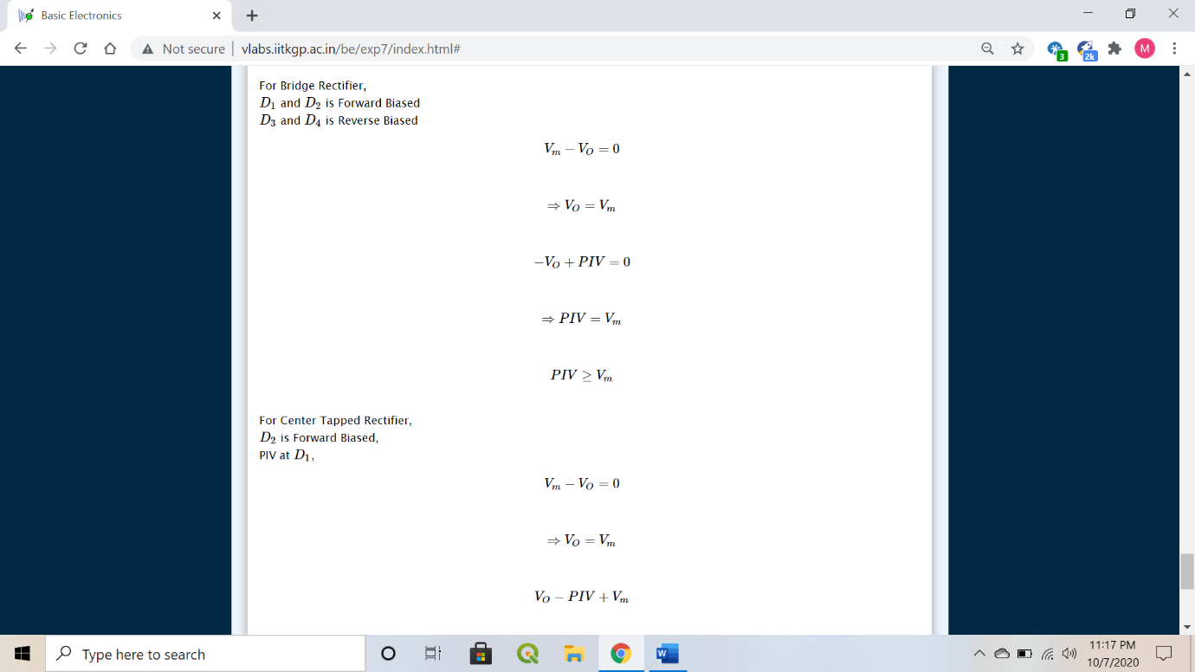

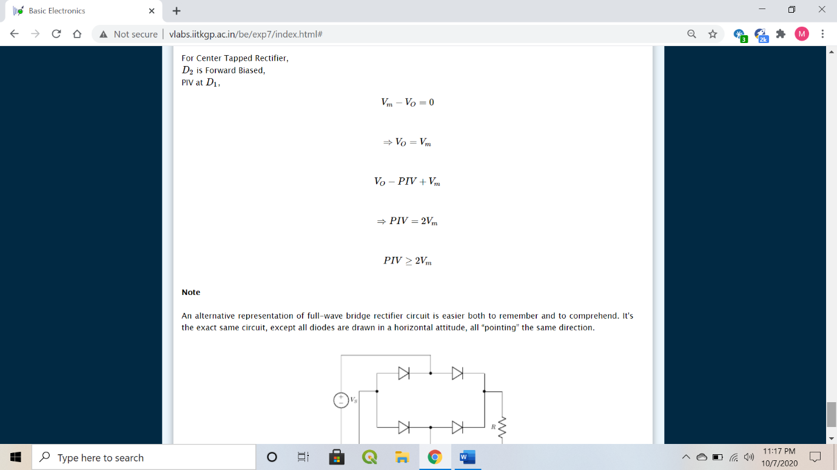

1. **Circuit (hand drawn/image)**

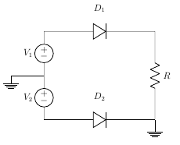**Full wave rectifier**

Circuit consists of two sources which have a phase difference along with two diodes. When V1 is positive, V2 is negative. Hence, D1 will be a short and D2 will be an open and vice-versa.

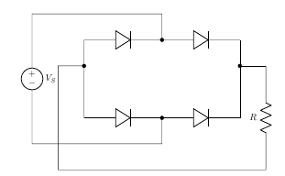 Alternative representation of full-wave bridge rectifier circuit.



Bridge rectifier



Centre tapped transformer

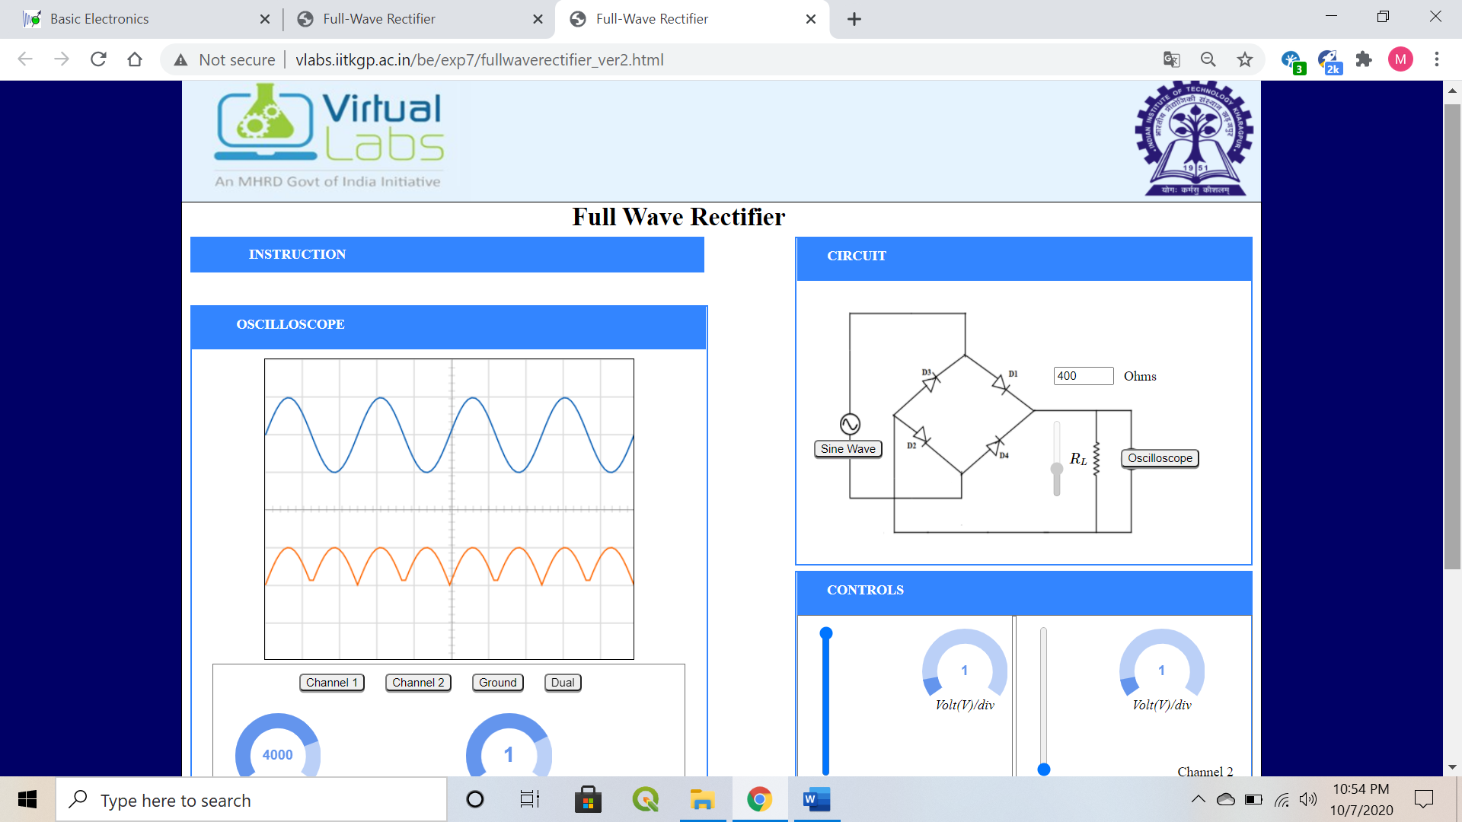

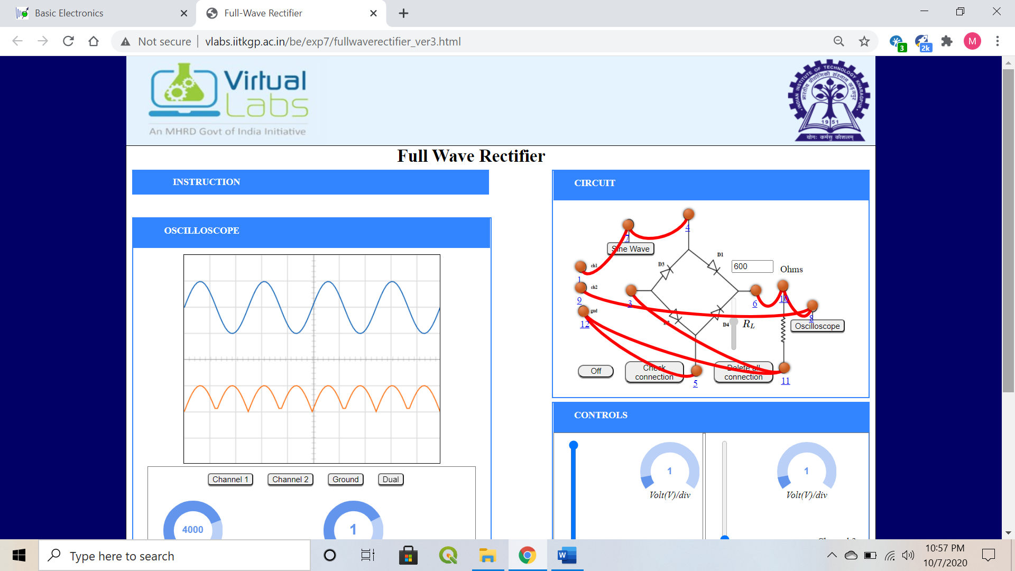

1. **Measurement Data (Tabular form)**

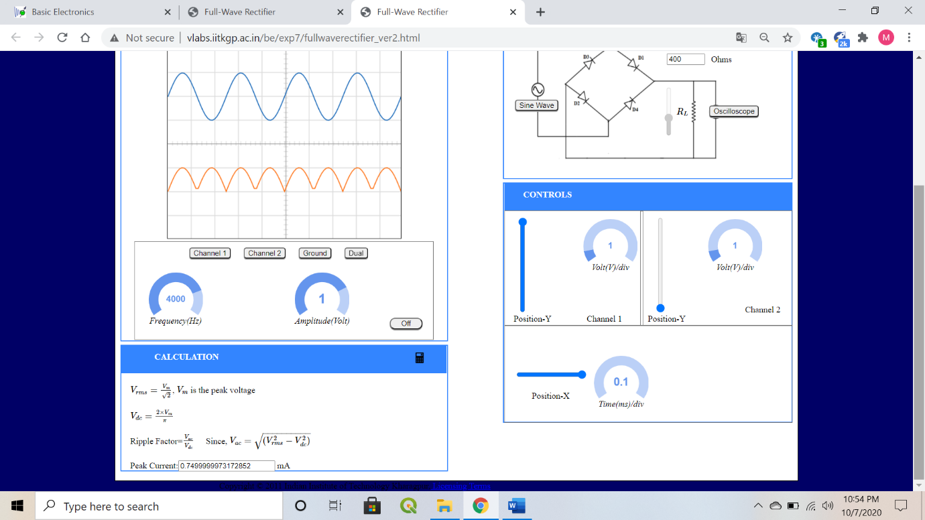

* + **Bridge Rectifier**
* **Load Resistance 400 ohms**
* **Load Resistance 600 ohms**

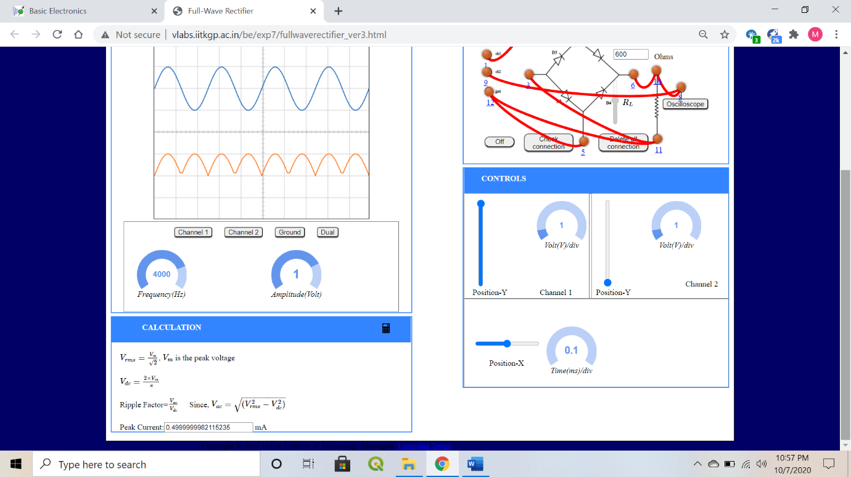

1. **Graph (Image)/Screenshots**

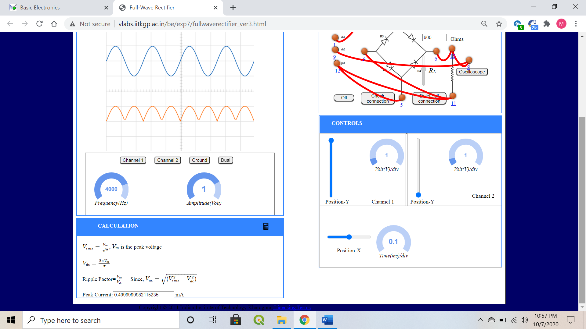

* **Load Resistance 400 ohms**

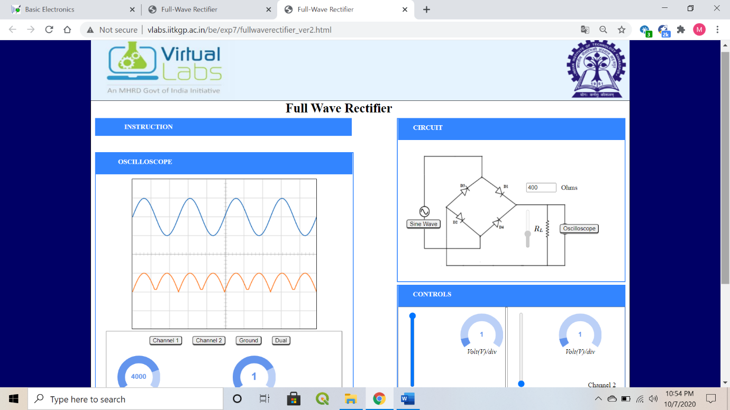

* **Load Resistance 600 ohms**

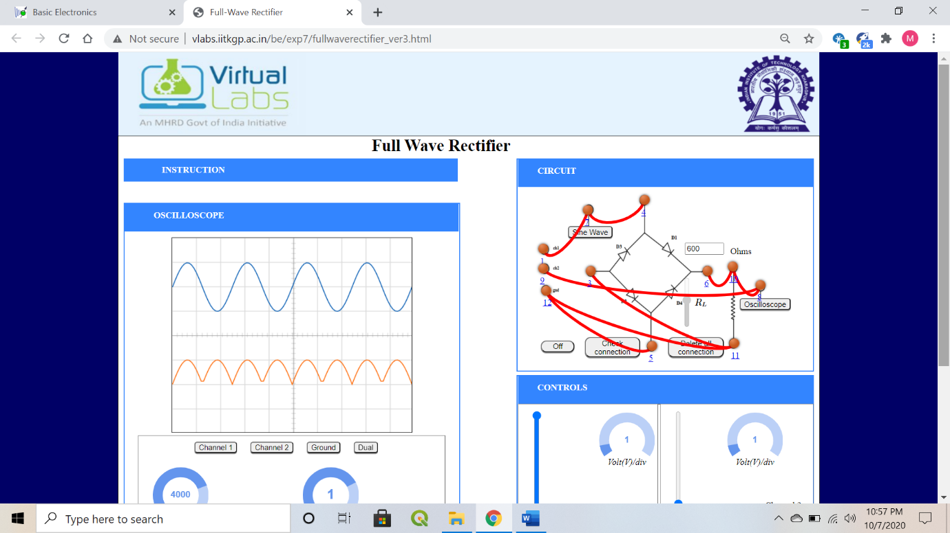

Orange🡪 output voltage

Blue🡪 input voltage

1. **Conclusion**

* Rectification: AC 🡪 DC
* A centre-tapped rectifier uses two diodes connected to the secondary of a centre-tapped transformer.
* A Bridge rectifier is a circuit arrangement which makes use of both half cycles of input AC and converts them to DC, using 4 diodes.

1. **Discussions**

* Increase in the load resistance, decreases the peak value of current.
* For different peak values of current or the load resistors the ripple factor for a bridge rectifier remains constant as 0.48.
* Efficiency of a full wave rectifier is double the half wave rectifier. (81.13 %)
* Lower power loss because no voltage signal is wasted in the rectification process.
* The output voltage of centre-tapped full wave rectifier has lower ripples than a half wave rectifier.
* Expensive
* Occupies more space

1. **Quiz**

